Horsin' Around
Grant-Kohrs Ranch National Historic Site
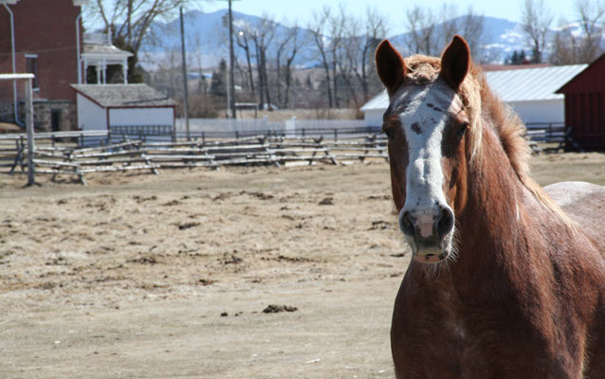
Belgian draft horse at Grant-Kohrs Ranch

GRADE LEVEL:
Fourth Grade-Sixth Grade
SUBJECT:
Agriculture, Biology: Animals, History, Social Studies
DURATION:
Five 55 min class periods
GROUP SIZE:
Up to 24
SETTING:
classroom
NATIONAL/STATE STANDARDS:
Social Studies Standards 3,4,5
Technology Content Stadards 1.1, 1.2, 1.5
Writing Content Standards 4.1a, 5.1a 6.1b
Language Common Core Standards –SL.4.1, SL5.1abc, SL6.1abc
Reading Common Core Standards -RL 4.1, RL6.1, RI4.1, RI4.3, RI6.1

Overview
Through this research-oriented lesson, students will learn about different breeds of horses. Then they will create a PowerPoint presentation of a breed of horse. The class will then take a field trip to the Grant-Kohrs Ranch NHS or other type of ranch to interact with and see different breeds of horses.

Objective(s)
- Students will understand the use of horses both historically and today.
- Students will create a presentation on a breed of horse
- Students will compare and contrast the traits of different breeds of horses

Background
This lesson may be used after talking about the introduction of the horse into the Americas or after a Native American unit in the social studies classroom.

Materials
For this lesson, you will need a computer for each student or pair of students, a computer with projector or a smartboard for PowerPoint presentations. Teacher and student rubrics are provided as well as an example PowerPoint presentation.

Procedure

Students can be grouped into groups of two or work individually.

Students begin research online and in library to find the following information: Breed of horse, Species name of horse, Photo of your horse, Origin of your horse, acceptable color, average Height, Type (cold or warm breed), Historical uses of breed, Todays uses of breed, Works cited (see attached lesson resources).

Students create a PowerPoint presentation on their breed of horse and give one to two questions they would like the class to learn from their presentation for the teacher to compile as a test at the end.

Assessment
Presentation of PowerPoint to the class (see rubric in lesson resources).
Each group will give the teacher one question from their presentation they want the class to remember. The teacher will compile those questions and give that as an assessment.

Park Connections
The Open Range Era of our nation's history would not have been possible without the use of the horse. Cowboys needed to be able to ride to roundup cattle and drive them to market. Throughout the history of ranching, many different breeds have been used.

Extensions
Students could do research and present on the history of the saddle horse, history of the draft horse, or horseshoeing. They could research and present information on reading horse brands or the history of horse brands.
Additional Resources

A long list of breeds of horses: www.theequinest.com/breeds

Vocabulary
Draft Horse Breeds - animals that have traditionally been bred over the centuries to pull a load, also referred to as “cold blooded”
Saddle Horse Breeds – smaller, faster horses that are breed for riding

